Town Team Sales Report

# Analytical Questions for Town Team Sales Data:

## 1. Best-selling Category

Which category is the best-selling in terms of quantity?  
- Best-selling category by value: Women’s Wear  
- Total Quantity: 678

## 2. Highest Revenue Region

Which region achieved the highest revenue?  
- Region with highest total sales: Mansoura  
- Total Sales: 64,890.15 EGP

## 3. Month with Highest Sales

Which month recorded the highest sales?  
- Best sales month: November  
- Total Sales for this month: 24,937.34 EGP

## 4. Day with Highest Sales

Which day recorded the highest sales?  
- Day with highest total sales: 2024-08-31  
- Total Sales: 2,855.21 EGP

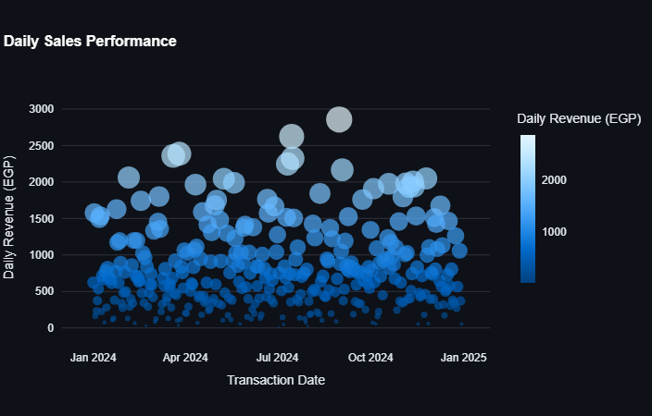

## 5. Top Spending Customer

Which customer spent the most on purchases?  
- Customer with highest total sales: C190  
- Total Amount: 5,610.98 EGP

## 6. Most Frequent Buyer

Which customer made the highest number of purchases?  
- Customer with the highest number of purchases: C099 , C190  
- Number of Purchases: 13

## 7. Most Profitable Product

Which product is the most profitable based on total sales?  
- Most profitable product: Scarf  
- Total Sales: 5,610.98 EGP

## 8. Least Profitable Product

Which product is the least profitable based on total sales?  
- Least profitable product: T-Shirt  
- Total Sales: 73.47 EGP

## 9. Relationship Between Unit Price and Quantity Sold

There is no relationship between the unit price and quantity sold.

## 10. Sales Distribution by Region

What is the total sales for each region?

|  |  |
| --- | --- |
| Region | Total Sales (EGP) |
| Mansoura | 64,890.15 |
| Alex | 63,305.60 |
| Tanta | 62,583.19 |
| Madinaty | 49,515.69 |
| New Cairo | 8,845.99 |
| Nasr City | 5,549.57 |

## 11. Seasonal Trends

Are there any seasonal trends in the sales?  
Yes, there is an increase in sales in May and November.  
This is because May marks the beginning of summer—resulting in higher demand for clothing—and November signals the beginning of winter.

## 12. Percentage Contribution by Category

What is the percentage contribution of sales by each category?

|  |  |
| --- | --- |
| Category | Percentage |
| Women’s Wear | 27.7% |
| Kids’ Wear | 27.5% |
| Men’s Wear | 24.1% |
| Accessories | 20.5% |

## 13. Average Order Value

What is the average order value (Total Sales)?  
- Minimum Sales: 10.83  
- Average Sales: 254.69019  
- Maximum Sales: 798.34

## 14. Total Quantity Sold per Product

What is the total quantity sold for each product?

|  |  |
| --- | --- |
| Product Name | Quantity |
| Polo Shirt | 290 |
| Scarf | 290 |
| Jeans | 245 |
| Socks | 206 |
| Belt | 190 |
| Gloves | 173 |
| Jacket | 151 |
| Hat | 120 |
| Dress | 105 |
| Sweater | 103 |
| Shorts | 102 |
| Watch | 98 |
| Shoes | 93 |
| Boots | 77 |
| Sandals | 67 |
| Skirt | 61 |
| Blazer | 56 |
| T-Shirt | 42 |

## 15. Highest Revenue Product

Which product generated the highest revenue?  
- Best-selling product by value: Scarf  
- Total Sales: 30,220.11 EGP

## 16. Quarterly Sales Change

How do sales change on a quarterly basis?  
There is a significant increase in sales in the third and fourth quarters compared to the first and second quarters.

## 17. Relationship Between Region and Best-Selling Category

Is there a relationship between the region and its best-selling category?  
Yes, there is a relationship; consumer preferences vary from one region to another.

## 18. Repeat vs. New Customers

What is the percentage of sales coming from repeat customers versus new customers?  
- New Customers: 0.74%  
- Returning Customers: 99.2%

## 19. Recommendations for Improvement

Based on the trends and patterns extracted from the data, the following recommendations are suggested:  
- Leverage Strengths: Focus on the high performance of Women’s Wear, especially in regions with high sales.  
- Expand Customer Base: Develop strategies to attract more new customers to balance the overwhelming percentage of repeat buyers.  
- Seasonal Strategies: Optimize inventory and promotional activities during peak sales months (May and November).  
- Reevaluate Underperformers: Consider revising pricing or marketing strategies for products that are underperforming, such as T-Shirts.